Indian Institute of Technology Indore
Advertisement for Admission to Ph.D. Program in Electrical Engineering (EE) for Spring Semester of Academic Year (AY) 2021-22

IITI/Acad/PhD Admissions/21-22 October 05, 2021

IIT Indore invites applications from highly motivated and research-oriented students for admission to its PhD program in the Department of Electrical Engineering for the Spring Semester of Academic Year (AY) 2021-22 as per the below-mentioned categories of admission and time schedule. Candidates can visit the profiles of the faculty members listed below at the link: http://ee.iiti.ac.in/faculty.html before applying.
Categories of admission (for Indian and International applicants): Refer to the main PhD advertisement available at https://academic.iiti.ac.in/phdadvt.php

Time Schedule of PhD admission:
Last date of online application through https://academic.iiti.ac.in:8443/nregistration.jsp (for Indian applicants) | November 9, 2021 (Tuesday)  Latest by 17.00 hrs. IST
Last date of online application through https://academic.iiti.ac.in:8443/nregistration.jsp (for International applicants) | November 9, 2021 (Tuesday)  Latest by 17.00 hrs. IST
Dates of PhD selection process | November 12 and 13, 2021 (Friday and Saturday)
Minimum Educational Qualifications (MEQs) and Qualifying Examination
For Indian Applicants: Master’s degree in Electrical/ Electronics/ Electronics & Communication / Physics / Instrumentation and Control Engineering / Material Science & Engineering / Biotechnology or any other equivalent degree with specialization in the areas of communication and signal processing or micro/nanoelectronics & VLSI area or power electronics and power systems/control systems (with first division as defined by the awarding Institute/University) having GATE qualification in EE/EC/IN subjects or UGC/CSIR/DBT - JRF qualification or DST INSPIRE fellowship or Equivalent fellowship.
OR
Four-year Bachelor’s degree OR five-year integrated degree in Electrical Engineering/ Electronics and Communication Engineering OR Electrical & Electronics Engineering/ Instrumentation & Control Engineering (with first division as defined by the awarding Institute/University) AND valid GATE qualification in EE/EC/IN only or UGC/CSIR/DBT - JRF qualification or Equivalent fellowship.

For International Applicants:
MEQ: Master’s degree in Electrical Engineering with specialization in either Communications & signal processing/ VLSI/ Nanoelectronics/ Image processing/ Speech processing/ RF-Microwave / Power electronics / Power systems / Control systems or any other related areas (with first division as defined by the awarding Institute/University)
QE: Valid TOEFL/IELTS or equivalent qualification OR valid GATE qualification

Instructions:
- All eligible candidates, fulfilling the minimum eligibility criteria, must apply online through the website (http://academic.iiti.ac.in:8080/nregistration.jsp).
- After applying online, the applicants should take a print out of the application form and sign the same. The scanned copy of
duly signed application form along with the following documents should be sent by email to admission-ee@iiti.ac.in
  - Self-attested photocopies/scanned originals of all relevant supporting documents such as degree certificates, mark sheets, date of birth certificate, fellowship award letter, GATE score card, etc., from ${10}^{th}$ class onwards that they wish to present before the selection committee.
  - Two recent passport size photographs.
  - Receipt of fee (Rs.100/-) paid through SBI i-collect.
  - Letters of recommendation duly signed by a minimum of two referees who have known the applicant in a professional capacity. The letters are mandatory for PhD selection process and must be sent directly to admission-ee@iiti.ac.in
The format of the recommendation letter can be found along with this advertisement.
- Important: DO NOT send any form or documents by post.
- Only shortlisted candidates will be called for online interviews, and the same will be shared by email to respective candidates. No emails or communication, in any form, regarding shortlisting process, change of interview date,
syllabus of interview, etc. will be entertained.
- Candidates who wish to appear for the PhD selection process and fulfill the eligibility criteria may also send their Resume/CV to the faculty member whose area is of interest to them. The areas of interest and detailed profile of faculty member is given below. Candidates are encouraged to visit webpage of faculty member listed below to know more about ongoing research work and areas of interest.
- Mere fulfillment of the minimum eligibility criterion does not entitle anyone for admission into the PhD program in Department of Electrical Engineering.
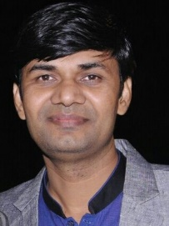  Dr. Mukesh Kumar | Brief description about the research group/research interests of faculties  Dr. Mukesh Kumar is leading Optoelectronic Nanodevice Research Laboratory (Opto Nano Group). His research interests include Optoelectronic Devices, VLSI Technology, Microwave Photonics, Nanoelectronics, Integrated Photonics and Device Fabrication. He has supervised 9 PhD-scholars. He is also serving as an adjunct-faculty at Purdue School of Engineering & Technology, IUPUI, USA. His research-group has ongoing-research-collaborations with leading-scientists in India, France, UK, Russia, South Korea, Germany, and USA. He is looking for motivated and hard-working PhD-candidates who are with a background in Electronics and related areas and are interested to work in the above-mentioned research-areas. For further details, please visit http://iiti.ac.in/people/~mukesh.kr. Contact: mukesh.kr@iiti.c.in.
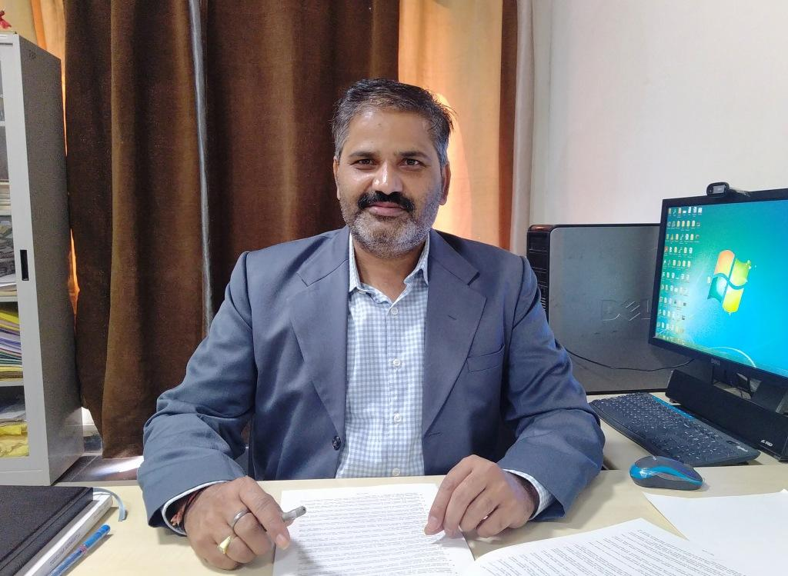  Prof. Ram Bilas Pachori | Prof. Ram Bilas Pachori works in the areas of Signal and Image Processing, Biomedical Signal Processing, Non-stationary Signal Processing, Speech Signal Processing, Brain-Computer Interfacing, Machine Learning, and AI and IoT in Healthcare. He has 232 publications which include journal papers (142), conference papers (66), books (06), and book chapters (18). His publications have around 9000 citations with an h-index of 49 as per Google Scholar. He has supervised 14 Ph.D. students for their theses. He is looking for the Ph.D. students to work in the above mentioned research areas. Please visit his homepage for more details: http://iiti.ac.in/people/~pachori/
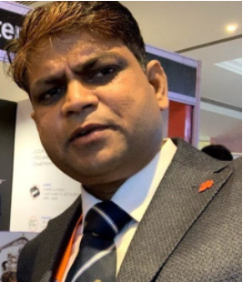  Dr. Santosh Kumar Vishvakarma | Dr. Santosh Kumar Vishvakarma is leading “Nanoscale Devices, VLSI Circuit and System Design” research group at IIT Indore. His research interests are VLSI Circuit and System design including Energy-Efficient and Reliable SRAM Memory Design; Enhancing Performance and Configurable Architecture for DNN Accelerators; SRAM based In-Memory Computing Architecture for Edge AI; Reliable, Secure Design for IoT Application and Design for Reliability. He has a very strong collaboration in Industry and Academia across India and globe. As of now, 13 PhD Scholars have been awarded from his group. For details, please visit: https://sites.google.com/site/svishvakarma/. He may be contacted at his email id skvishvakarma@iiti.ac.in
Dr. Shaibal Mukherjee | Hybrid Nanodevice Research Group (HNRG) led by Dr. Shaibal Mukherjee works in advanced devices in Nanofabrication; RRAMs in Image Processing, Artificial Intelligence and Data Security; Solar Cells, RF Transistors, Biochemical sensor (http://iiti.ac.in/people/~shaibal/). HNRG has strong collaborative research partners with industries and institutions in India and in the USA, Russia, France, Portugal, Israel, Italy, Japan, Australia, Sweden, and Germany. Bright and inspired candidates, having a background in Electronics / Physics / Materials Science / Biotechnology / Computer science are strongly encouraged to apply. Till date, 15 PhD students have graduated by completing their research at HNRG.  Former PhD graduates from HNRG are successfully placed in IIT, NIT, IIIT, and Japan (http://iiti.ac.in/people/~shaibal/phd_graduated.php). For details, contact at shaibal@iiti.ac.in
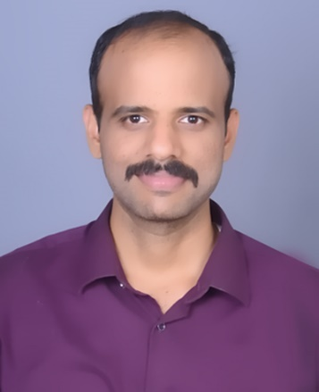  Dr. Swaminathan R. | Dr. Swaminathan’s (swamiramabadran@iiti.ac.in) Future Generation Communication Systems research group at IIT Indore works on Efficient Design of Space-Air-Ground Integrated Networks (SAGIN) with Hybrid Optical-RF Wireless Communications, Development of Novel Algorithms for Blind Parameter Estimation of Forward Error Correcting Codes and Interleavers, 5G and Beyond Wireless Systems, Index Modulation Techniques for Next-Generation Wireless Communications, Energy Harvesting Schemes for Integrated Optical-RF Networks, Intelligent Reflecting Surfaces (IRS) Aided Communications, etc. Dr. Swaminathan is the author or co-author of 21 International journal publications including 14 publications in reputed IEEE Journals/Transactions/Letters.  For more details please refer to https://swamiramabadran.wixsite.com/website
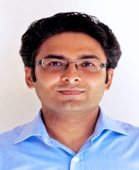  Prof. Vimal Bhatia | Prof. Bhatia (http://iiti.ac.in/people/~vbhatia / vbhatia@iiti.ac.in) is leading collaborations with researchers from the UK, Ireland, Norway, Finland, France, Canada, South Africa, and the US, with external funding from DST, MeitY, UKIERI, AKA Finland, IUSSTF, and MHRD/MoE. Actively involved in R&D on a) Performance analysis of beyond 5G/6G communications, b) OFDM, MIMO, NOMA, Cognitive Radio, Visible Light Communications, c) Bio-inspired image processing, biometry, radar using machine and deep learning algorithms.  Bright and highly motivated candidates, having background in Communications/Signal Processing /Mathematics/Statistics/Electronics/ElectricalSciences/Electrical Engineering/Computer Science or equivalent are encouraged to apply. Former post-graduate students placed in IIT, NIT, IIIT, NMIMS, Australia, UK, EU, and Qualcomm.
Dr. Vipul Singh | Dr. Vipul Singh’s research group MNRG focuses on wide range of topics primarily related to Organic electronics, Oxide based semiconductors, LSPR effect, Optoelectronic devices, Bio/chemical/gas sensors, synthesis of nanostructured materials. MNRG strives for academically brilliant and motivated candidates having past background in Electrical/Electronics/ Instrumentation engineering/ Material Science & Engineering and Applied Physics and having passion to pursue research at the forefront of nanoelectronics and allied areas. Fellowship awardees are encouraged to apply to our group under FA category. For more details please visit our homepage: http://www.iiti.ac.in/people/~vipul/ , for more details contact me at vipul@iiti.ac.in
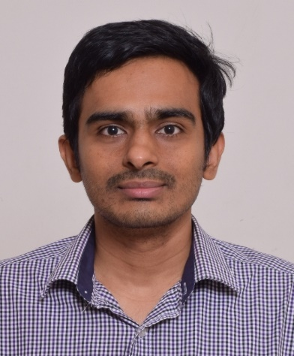 Dr. Vivek Kanhangad  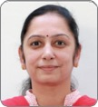  Dr. Trapti Jain  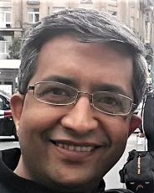  Prof. Abhinav Kranti  (akranti@iiti.ac.in)  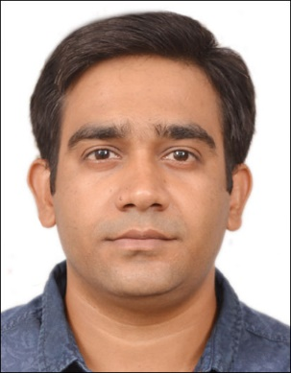  Dr. Saptarshi Ghosh  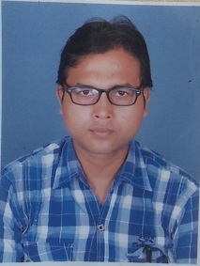  Dr. Abhinoy K Singh  Dr. Nitya Tiwari | Dr. Vivek Kanhangad’s research group at IIT Indore conducts theoretically sound and application-oriented research in the overlapping areas of image analysis, computer vision and machine learning with focus on biometrics and biomedical applications. Specifically, the areas of our current research include video analysis using deep learning for safety of autonomous vehicles, high-resolution fingerprint matching, biometric solutions for smartphones, and attack detection in biometric systems. The applicants should be highly motivated with an excellent academic record and programming skills. For more details, please visit http://iiti.ac.in/people/~kvivek/  Dr. Trapti Jain's research group at IIT Indore works on various operational issues related to smart grid. Currently, the focus of our group is towards data analytics in smart grid, synchrophasor applications to power systems and developing control algorithms to enhance dynamic performance of islanded microgrids. The applicants having a strong background in power systems and control systems would be preferred. The applicants should be highly motivated with an excellent academic record and good programming skills. For more details, please visit the following websites.  URL. https://people.iiti.ac.in/~traptij/ Research Group: https://poweriiti.weebly.com  Low Power Nanoelectronics Research Group is engaged in pioneering research on capacitorless DRAM, steep switching transistors, material-device-circuit co-design and vertically stacked transistors, all of which are essential for the development of next generation logic and memory technology. The group has very strong collaborations with leading international researchers, and after completing PhD, students often receive offers for post-doctoral positions abroad. Exceptionally talented and motivated candidates, with strong interest in Semiconductor Devices, CMOS, Nanoelectronics, Biosensors, VLSI and Circuit Design intending to work on emerging research problems are strongly encouraged to apply. For more information, please visit: http://iiti.ac.in/people/~akranti/  Dr. Saptarshi Ghosh is leading the research group in Applied Electromagnetics Laboratory at the Department of Electrical Engineering, IIT Indore, India. His areas of research interest include electromagnetics, frequency selective surfaces, metamaterials, absorbers, antennas, and other microwave devices. He is also working on various cutting-edge technologies, such as 3-D printing, Inkjet printing, and 5G wireless communication. Motivated candidates, having a strong background in Electromagnetics and related areas, are highly encouraged to apply. For more information and recent publications, please visit the weblink: http://iiti.ac.in/people/~sghosh/  We work on stochastic control, especially on estimation and filtering algorithms. These algorithms are crucial in analyzing various inappropriate data and providing computationally efficient alternatives to several machine learning algorithms. We also work on drone-data based estimation and filtering applications. In future, we plan to apply the estimation and filtering for many more state-of-art industrial applications, such as predictions (market prediction, price forecasting, etc.), defense (target tracking, interception, navigation, etc.), monitoring (health monitoring, financial monitoring, etc.), etc. A potential candidate interested in stochastic control or any of the mentioned applications is welcome in our lab.  Email: abhinoy.singh@iiti.ac.in  Website: http://people.iiti.ac.in/~abhinoy.singh/  Dr. Nitya Tiwari works in the areas of signal processing and speech processing, particularly speech enhancement for listeners with hearing impairment. Her research interests include development of signal processing based and machine learning based techniques for single microphone and multi-microphone speech enhancement. She is also interested in development of real-time noise suppression algorithms with low memory, latency, and computational complexity for use in hearing assistive devices. She is looking for Ph.D. students who have background in and are keen to work in above mentioned areas.  Email: hlnityatiwari@gmail.com  Website: https://sites.google.com/view/nityatiwariiiticom/home

For any queries, please contact:
Dr. Swaminathan R (DPGC Convener),
Department of Electrical Engineering,
Indian Institute of Technology Indore, Indore - 453552, India
E-mail: admission-ee@iiti.ac.in

